11. **Identify the harmful impacts & mitigation measures the Environmental, Health, and Social Impact Assessment (EHSIA) states that the company will bring.** The EHSIA states the harmful impacts of their activity and their proposed mitigation measures (mitigation measures are the actions that help compensate for the harmful impact). For example, a company may state that one harmful impact will be increased air pollution due to drilling and truck traffic. It may state that its mitigation measure will be to soak worksite area with water to reduce air pollution. Make a list of the mitigation measures that the company has not yet done.

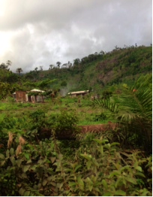

12. **Ask and negotiate for what you want.** Using your lists, remind your tribal authorities that the company has made a commitment and the company has a duty to follow through on the terms of that commitment. This includes their promises for benefits to the community (for example, schools, clinics, roads, and jobs) *and* mitigation measures (for example, soaking cleared areas with water).



**Good luck! And remember…**

* Your community has the right to be involved in land matters that affect your ownership, management, and use of the land.
* Make sure everyone in your community is included in all discussions – including elders, women, youth, and minorities.
* Take time to fully discuss everything and consider everyone's opinions.
* Remember the value in long-term peace, stability, and land access for your community and your children.
* If in doubt, you can always refer to a trusted NGO for advice.



**Advocating for Land Rights**

**After a Lease Has Been Signed**

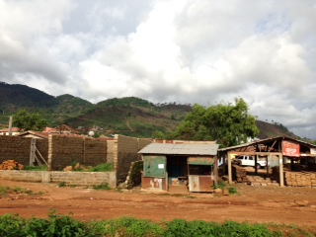

This brochure explains steps communities may take to protect their rights *after* a lease agreement has been concluded with an investor.

For advice on how to protect land *before* a lease agreement has been signed, please see Namati’s brochure “How to Protect Your Community’s Land and Natural Resources”

If you are in need of advice, contact

**Namati**:

31 Murray Town Road, Freetown

076926090; 078717335

Or **Silnorf**:

Makeni-Magburaka Highway, P.O. Box 5, Makambo/Makeni

076715232; 033412188;

088413527; 078732131

**If there is a current agreement with an investor that is harming your community or members of your community . . .**

1. **Form a temporary committee of landowners, land users, women and traditional authorities to discuss what harms you are facing and what you would like to see done**. Remember, your community has the right to assert interests in owning, managing and using the land.

2. **Do everything out in the open as much as possible** and involve the whole community to discuss the investor’s plans, your grievances, and what the community would like to see change.

3. **Develop rules for how this temporary committee will operate and make decisions**. For example, your rules should emphasize that major decisions are to be made together. The committee should agree to consult with the entire community before making decisions.



4. **Discuss the value of long-term peace and stability and honestly discuss protocol about being offered one-off compensation to appease concerns.** Discuss the protocol of the committee. Be honest about what individuals want so that everyone is on the same page and can speak with a unified voice. It is better to be honest about what individuals want in the beginning of discussions rather than confront the divisions later on. Remind the community of the value of long-term peace, stability, and land access for your community and your children.

5. **Encourage the community to remain calm and peaceful as you work through the problem together.** Contact Namati, Silnorf or any trusted NGO to help obtain legal assistance.

6. **Don’t rush** any decisions. Hold as many meetings as you need and make sure that the whole community is involved in deciding what they would like to see change.

7. **When possible,** **engage your traditional authorities to ask them to communicate your concerns with the investor’s “point person**.” Explain the grievances and what the community would like to see done. Encourage the traditional authorities to communicate these concerns with the investor’s point person.

8. **Educate yourselves about the investment.** Get as many details as you can about the plan, including what the agreed-price was, the number of acres, and potential future impacts and benefits on your community.

9. **Obtain a copy of the lease agreement.** The lease agreement has information on the payment, number of acres, and investor activities. The lease agreements for African Minerals, London Mining, Octea Mining, Sierra Rutile, and Vimetco are available online at <http://www.nma.gov.sl> Contact Namati, Silnorf or any trusted NGO for assistance in obtaining copies of lease agreements or for understanding the terms of the agreements.

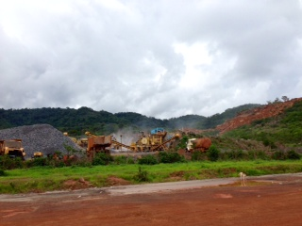

10. **Obtain a copy of the company’s Environmental, Health, and Social Impact Assessment (EHSIA) for your site. The company is required by law to have created a EHSIA** Contact Namati, Silnorf or any trusted NGO for assistance in obtaining the EHSIA or a summary of it.